New England Cuers

Massachusetts Cuers
781-223-2986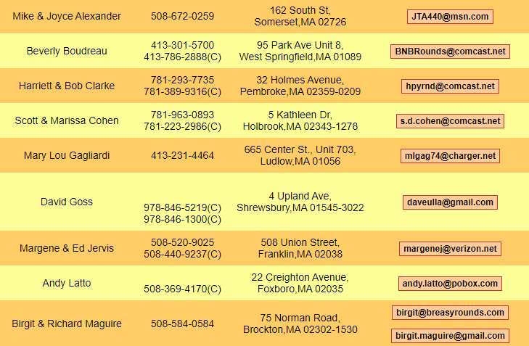
774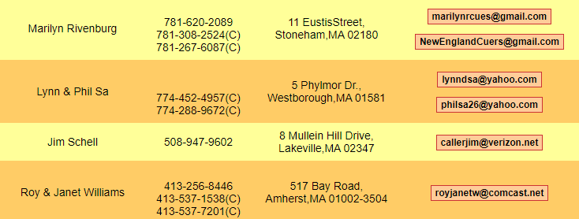

No Connecticut Cuers
Rhode Island Cuers

Maine Cuers
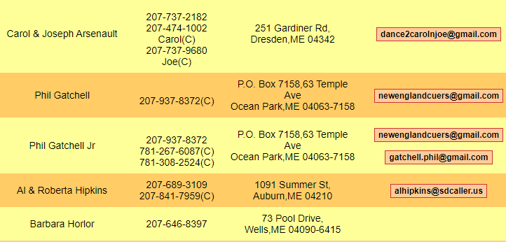

New Hampshire Cuers

Vermont Cuers

